TASK 9
Deploying a Simple Node.js Application on AWS Elastic Beanstalk

Umar Satti

Table of Contents
Task Description 3
Architecture Diagram 3
Task 1: VPC Configuration 4
Task 1.1: Create VPC 4
Task 1.2: Create Internet Gateway 4
Task 1.3: Create NAT Gateway 5
Task 1.4: Create Subnets 6
Task 1.5: Create Route Tables 7
Task 1.6: Setting up Routes for Route tables 8
Task 1.7: Route Table Association 9
Task 1.8: Security Groups 10
Task 2: Elastic Beanstalk 12
Task 2.1: Create Elastic Beanstalk application 12
Task 2.2: IAM Roles and Permissions 12
Task 2.2.1: IAM Service Role for Elastic Beanstalk 12
Task 2.2.2: IAM Role for EC2 Instances 13
Task 2.3: Configure an Elastic Beanstalk Environment 14
Step 1: Configure environment 14
Step 2: Configure service access 15
Step 3: Set up Networking, database, and tags 15
Step 5: Configure updates, monitoring, and logging 18
Step 6: Review 19
Task 3: Verify Infrastructure Deployment 21
Verify EC2 Instances are launched 21
Verify Target Groups 21
Verify Autoscaling Group 21
Verify ALB is working 22
Amazon SNS 23
CloudWatch Log groups 24
Environment Health 25
CloudWatch Alarms 25
CloudWatch Alarm Conditions 26
Using CloudWatch Alarms 26
Task 4: Update Application Code and Redeploy 29
4.1 Prepare Updated Application Code 29
4.2 Upload Updated Code in Elastic Beanstalk 29
4.3 Validate the Deployment 30
Task 5: Clean Up 31
Task 6: Troubleshooting 33

Task Description
This task involves deploying a Node.js application to AWS Elastic Beanstalk using the AWS Management Console. It includes creating the application and environment, uploading and deploying application code, configuring platform and scaling settings, enabling monitoring and health checks, and validating the deployment through Elastic Beanstalk endpoints and CloudWatch metrics.

Architecture Diagram
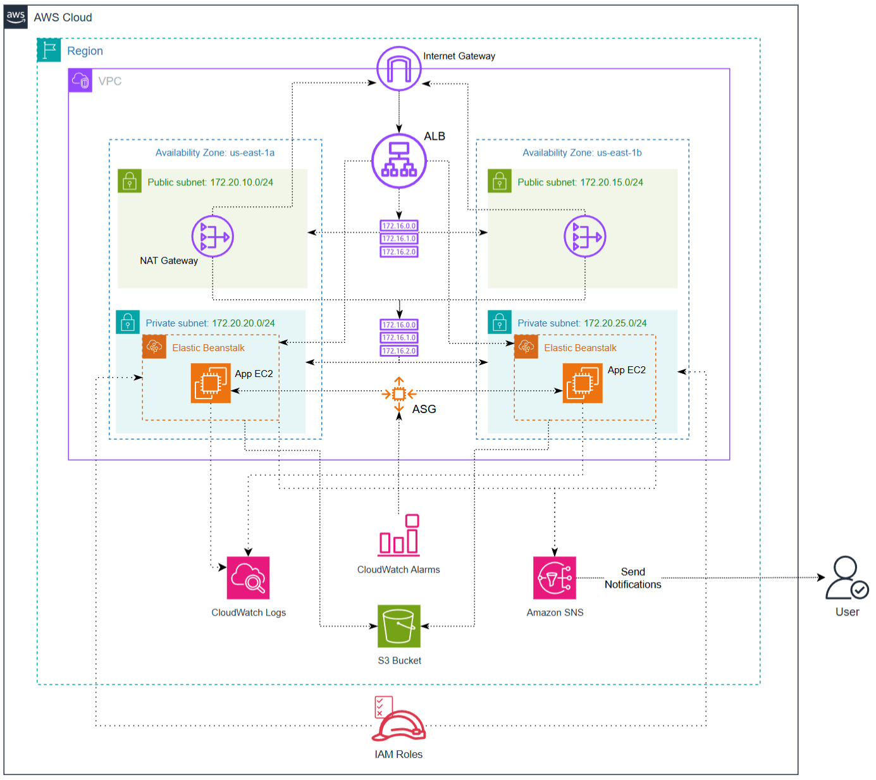

Task 1: VPC Configuration

Task 1.1: Create VPC
A Virtual Private Cloud (VPC) is a logically isolated network environment within AWS, allowing the creation of secure and private infrastructure.
Steps:
- Sign in to the AWS Management Console.
- Navigate to VPC service using the search bar at the top.
- In the VPC Console, click Your VPCs.
- Click Create VPC button on the top right.
- Choose VPC only option for ‘Resources to create’.
- Choose a name for the VPC and add an IPv4 CIDR block.
- Leave the Tenancy as Default.
As shown in the image below, under Details tab, a VPC has been created with the following configuration:
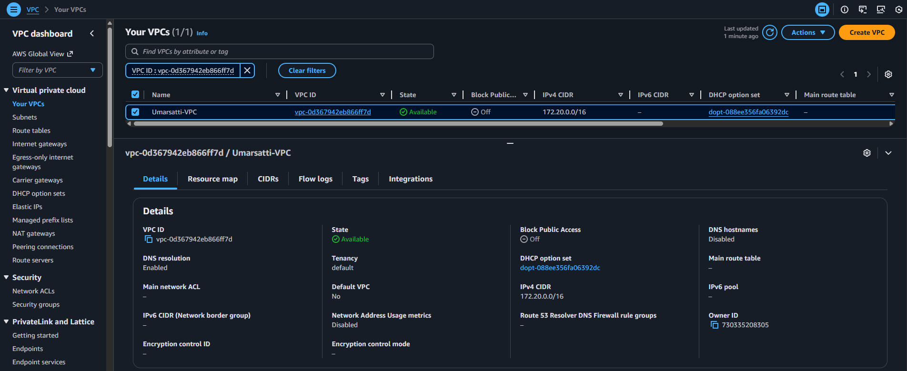
- Name: Umarsatti-VPC
- IPv4 CIDR range: 172.20.0.0/16
- VPC ID: vpc-0d367942eb866ff7d

Task 1.2: Create Internet Gateway
An Internet Gateway (IGW) enables communication between instances in the VPC and the public internet.
Steps:
- Within the VPC Console, click Internet gateways.
- Click on Create internet gateway button.
- Choose a Name and add optional Tags.
- Click Create internet gateway button. This creates an Internet gateway outside the VPC, and it needs to attach to the VPC created earlier.
- Select Actions on the top right and click Attach to VPC. Choose the VPC ID (created earlier) and click Attach internet gateway. This attaches the Internet gateway to the VPC, allowing internet access.
As shown in the image below under Details tab, an internet gateway has been created with the following configuration:
- Name: Umarsatti-IGW
- State: Attached
- VPC ID: vpc-0d367942eb866ff7d
- Internet gateway ID: igw-074c1a06c2be76990
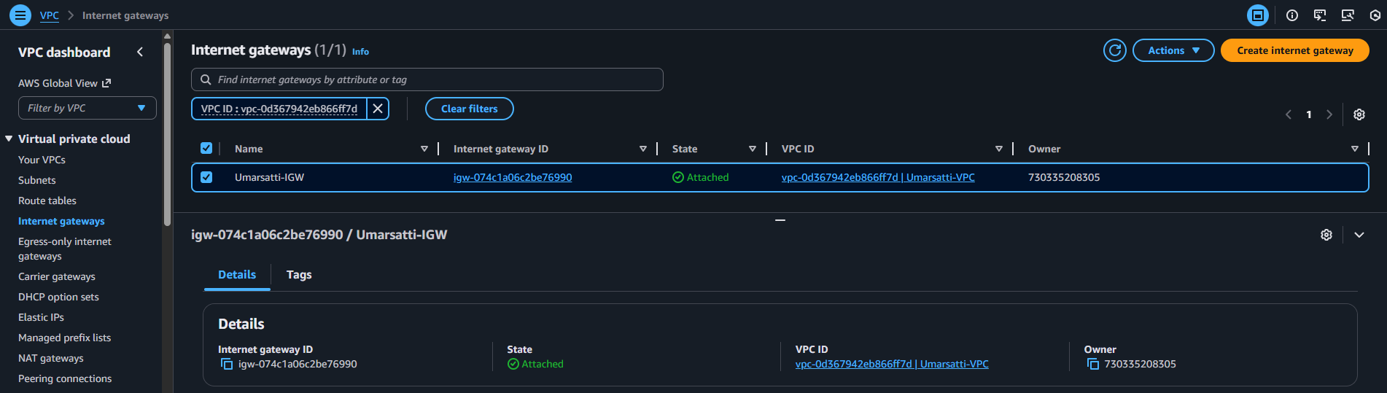

Task 1.3: Create NAT Gateway
A NAT Gateway (Network Address Translation Gateway) provides outbound internet access to private instances without exposing them to inbound traffic.
Steps:
- Within the VPC Console, click NAT Gateways.
- Click on Create NAT gateway button on the top right.
- Choose Availability mode as Zonal. This helps attach NAT gateway in public subnet.
- Choose a Name, Subnet, Connectivity type, Elastic IP allocation ID, and optional Tags.
- When done, click on Create NAT gateway button to create the resource.
As shown in the image below under NAT gateways section, a NAT gateway is created with the following configuration:
- Name: Umar-NAT
- NAT gateway ID: nat-0509686e7db17bc00
- Connectivity type: Public
- VPC: Umarsatti-VPC
Note: When creating the NAT Gateway, click on Allocate Elastic IP option. This automatically generates an Elastic IP for NAT Gateway resource.
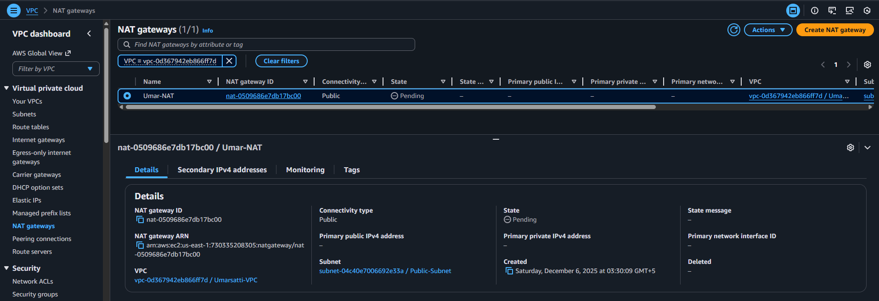
NAT Gateway is set up in the public subnet and assigned an Elastic IP. The private EC2 instances can communicate externally without being directly reachable from the internet. This maintains a secure boundary for private subnets.
Note: For high availability and fault tolerance, create a NAT gateway in each public subnet. For this project, only a single NAT gateway has been deployed in Public Subnet A (but diagram indicates two).

Task 1.4: Create Subnets
Steps:
- Within the VPC Console, click Subnets.
- Click on Create subnet button.
- Choose a Subnet name, Availability Zone, IPv4 VPC CIDR block, IPv4 subnet CIDR Block and optional Tags.
- Repeat this process by clicking on Add new subnet button at the bottom to add more subnets (Public and Private).
- After adding the required subnets, click on Create subnet button at the bottom right.
As shown in the image below under Subnets section, four subnets have been created with the following configuration:
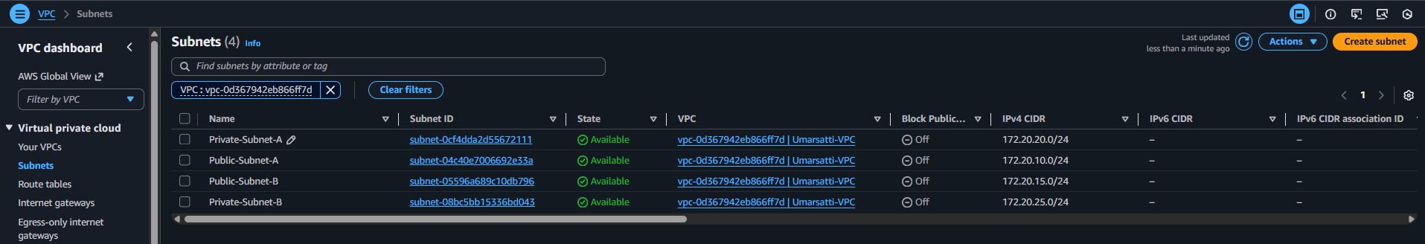
Public Subnet in us-east-1a:
- Name: Public-Subnet-A
- IPv4 CIDR: 172.20.10.0/24
Public Subnet us-east-1b:
- Name: Public-Subnet-A
- IPv4 CIDR: 172.20.15.0/24
Private Subnet us-east-1a:
- Name: Private-Subnet-A
- IPv4 CIDR: 172.20.20.0/24
Private Subnet us-east-1b:
- Name: Private-Subnet-B
- IPv4 CIDR: 172.20.25.0/24
In this design:
- The Public Subnet hosts internet-facing resources (e.g., Load Balancer).
- The Private Subnets host internal EC2 instances running via Elastic Beanstalk and Auto Scaling Group.

Task 1.5: Create Route Tables
Route Tables define how network traffic moves within the VPC. Each route table directs traffic either internally (within the VPC) or externally (to the internet or a NAT gateway).
Steps:
- Within the VPC Console, click Route tables.
- Click on Create route table button on the top right.
- Choose a Name, VPC, and optional Tags.
- When done, click on Create route table button to create the resource.
As shown in the image below under Route tables section, two route tables have been created (excluding default route table) with the following configuration:
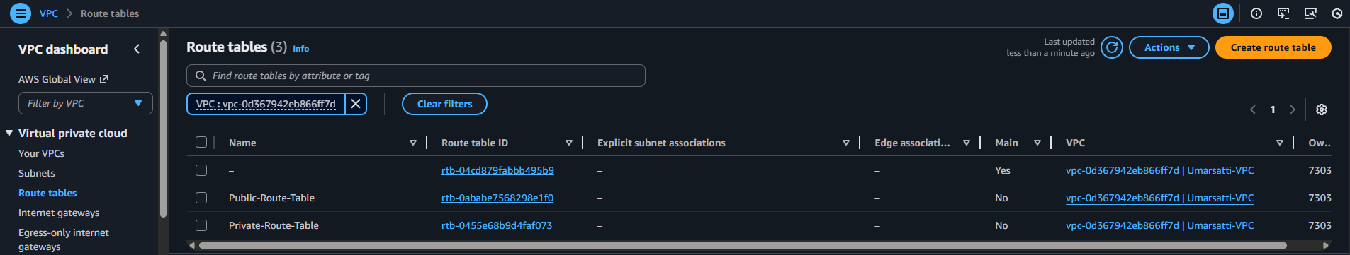
Public Route table:
- Name: Public-Route-Table
- Route table ID: rtb-0ababe7568298e1f0
Private Route table:
- Name: Public-Route-Table
- Route table ID: rtb-0455e68b9d4faf073
In this configuration:
- The Public Route Table directs internet-bound traffic to the Internet Gateway.
- The Private Route Table forwards internet-bound requests through the NAT Gateway (set up in Task 1.3), maintaining private subnet isolation.
This ensures clear routing logic between internal and external networks.

Task 1.6: Setting up Routes for Route tables
Steps:
- Within the Route tables console, select a Route table (example: Public-Route-Table) and click Edit routes on the right.
- Add a new route by choosing a Destination and Target.
- Click Save changes. This adds a route to this route table.

Public Routes (Public-Route-Table):
- Destination: 0.0.0.0/0
- Target: Umarsatti-IGW | igw-074c1a06c2be76990 (Internet gateway)
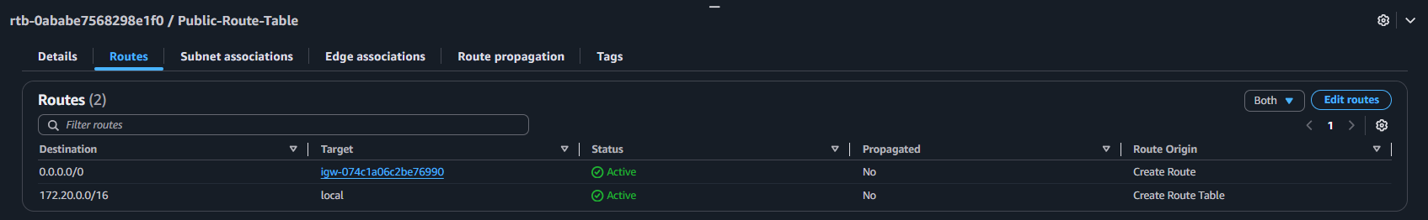
Private Routes (Umar-Pr-Rt):
- Destination: 0.0.0.0/0
- Target: Umar-NAT | nat-0509686e7db17bc00 (NAT gateway)
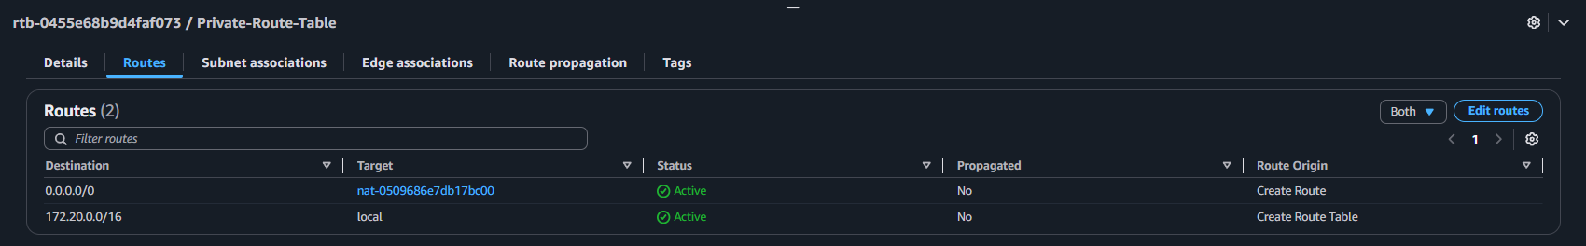
This step defines how traffic flows between subnets and external networks:
- The Public route table sends all internet-bound traffic (0.0.0.0/0) to the Internet Gateway, enabling access for public resources like the load balancer DNS.
- The Private route table provides internet-bound traffic through the NAT Gateway, allowing private EC2 instances to initiate outbound connections without exposure to the internet.

Task 1.7: Route Table Association
Steps:
- Within the Route tables console, select a Route table (example: Public-Route-Table) and click Subnet associations tab under the details section.
- Click Edit subnet associations and select the specific subnet (e.g. nginx-public-subnet)
- Click Save associations button on the bottom right.
Public Route table Subnet associations
- Names: Public-Route-Table
- Subnets: Public-Subnet-A and Public-Subnet-B
- IPv4 CIDR: 172.20.10.0/24 and 172.20.15.0/24
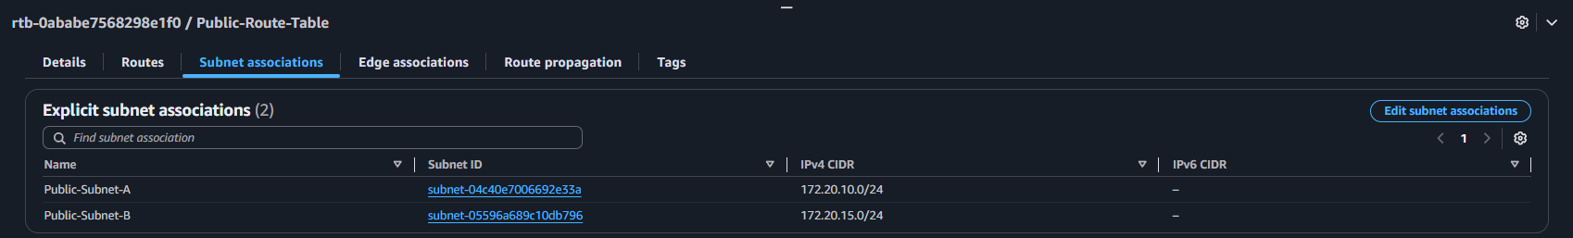

Private route table Subnet Associations
- Names: Private-Route-Table
- Subnet IDs: Private-Subnet-A and Private-Subnet-B
- IPv4 CIDR: 172.20.20.0/24 and 172.20.25.0/24
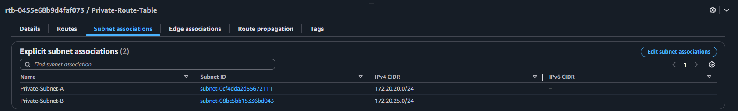

Each subnet must be linked to a route table to control its network traffic.
Associating subnets ensures:
- Public Subnet uses the Internet Gateway for external communication.
- Private Subnets use the NAT Gateway for secure outbound traffic.
Without this association, subnets would rely on the default main route table, potentially misrouting traffic.

Task 1.8: Security Groups
Security Groups act as virtual firewalls that regulate inbound and outbound traffic at the instance level.
Steps:
- Within the VPC Console, click Security Groups.
- Click on Create security gateway button on the top right.
- Choose a Security group name, Description, and VPC (Umarsatti-VPC).
- Add Inbound rules by selecting Type, Protocol, Port range, Source, and Description (optional).
- Leave Outbound rules as default (All traffic).
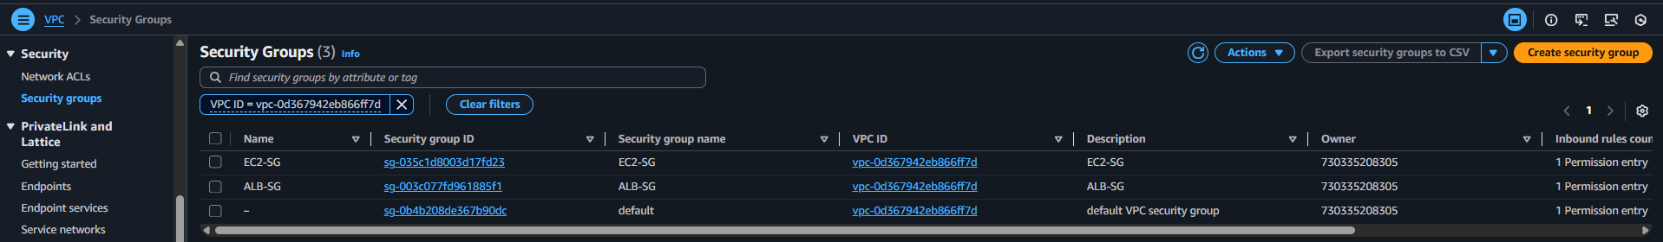

Task 1.8.1: Application Load Balancer Security group (ALB-SG)
Here is the configuration for the public subnet security group:
- Security group name: ALB-SG
- Security group ID: sg-003c077fd961885f1
- Inbound Rules:
Type | Protocol | Port range | Source
HTTP | TCP | 80 | 0.0.0.0/0
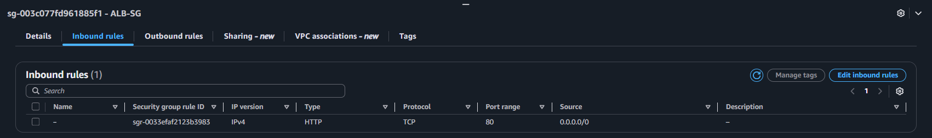
Task 1.8.2: EC2 Instance Security group (EC2-SG)
Here is the configuration for the public subnet security group:
- Security group name: EC2-SG
- Security group ID: sg-035c1d8003d17fd23
- Inbound Rules:
Type | Protocol | Port range | Source
Custom TCP | TCP | 5000 | ALB-SG

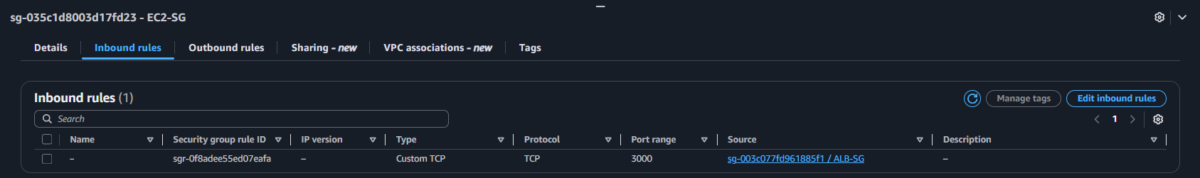
In this configuration:
- ALB-SG: Allows HTTP (port 80) from any external source.
- EC2-SG: Allows TCP port 5000 traffic from ALB-SG.
This layered security model follows the principle of least privilege, ensuring only the load balancer can reach private EC2 instances
Defining a custom VPC (e.g., using CIDR 172.20.0.0/16) provides control over the IP address range, subnets, routing, and security configurations. This VPC serves as the foundational network for deploying both public and private resources while maintaining clear separation and security boundaries.

Task 2: Elastic Beanstalk
Elastic Beanstalk is used to deploy web applications into the AWS Cloud on a variety of supported platforms. Users build and deploy their applications. Elastic Beanstalk provisions Amazon EC2 instances, configures load balancing, sets up health monitoring, and dynamically scales the environment.

Task 2.1: Create Elastic Beanstalk application
Steps:
- Sign in to the AWS Management Console.
- Navigate to Elastic Beanstalk service using the search bar at the top.
- In the Elastic Beanstalk Console, click Applications on the left navigation bar.
- Click Create application button on the top right.
- Choose Application name, Description, and Tags. Click Create button after to create this resource.
As shown in the image below, an Elastic Beanstalk application has been created with the name nodejs-application.
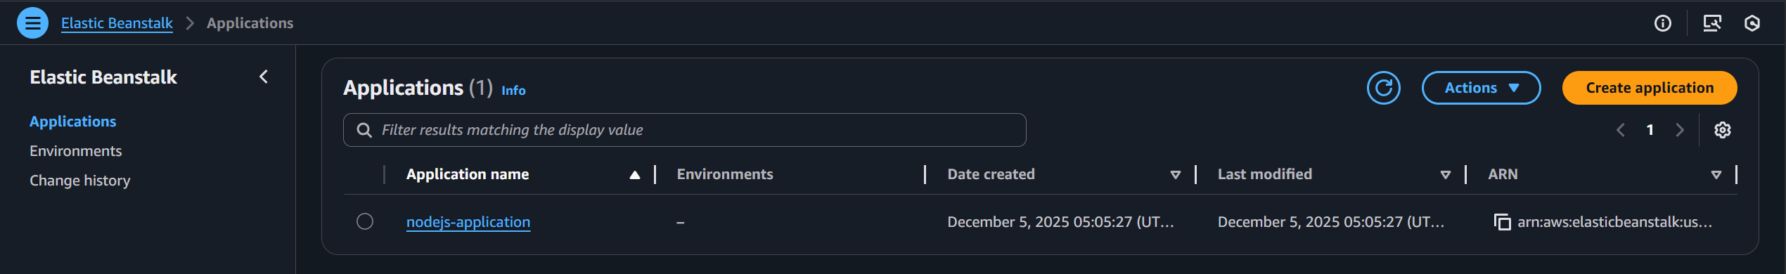

Task 2.2: IAM Roles and Permissions

Task 2.2.1: IAM Service Role for Elastic Beanstalk
- Role name: aws-elasticbeanstalk-ec2-role
- IAM Policies attached:
  - AWSElasticBeanstalkEnhancedHealth
  - AWSElasticBeanstalkManagedUpdatesCustomerRolePolicy
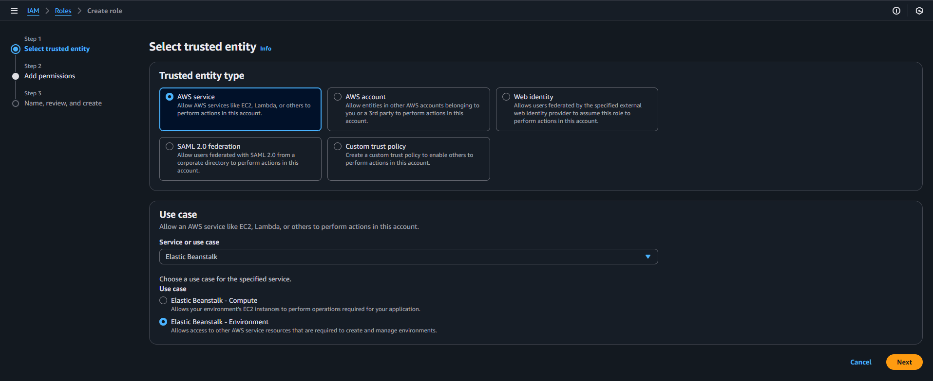
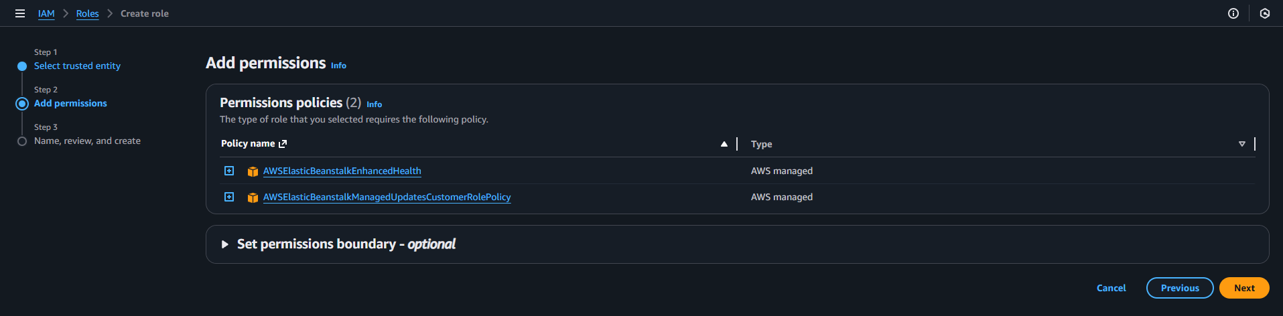

Task 2.2.2: IAM Role for EC2 Instances
- Role name: aws-elasticbeanstalk-ec2-role
- Add permissions
  - AWSElasticBeanstalkMulticontainerDocker
  - AWSElasticBeanstalkWebTier
  - AWSElasticBeanstalkWorkerTier
  - AmazonSSMManagedInstanceCore
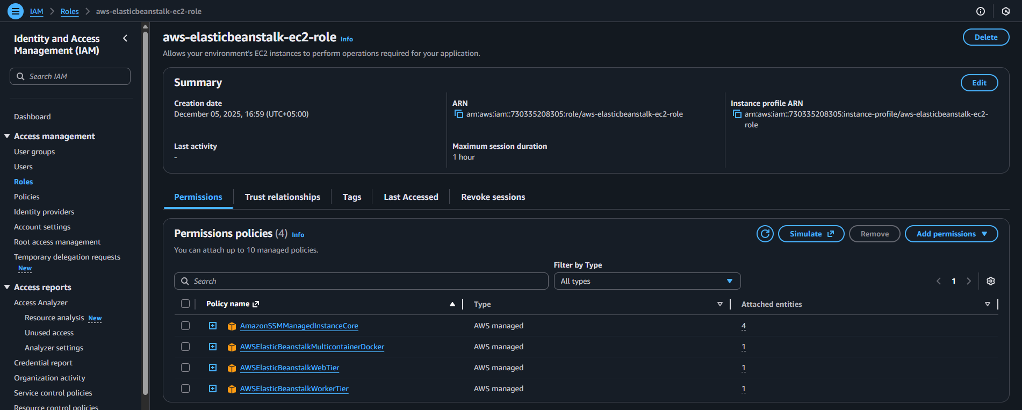

Task 2.3: Configure an Elastic Beanstalk Environment
- In the Elastic Beanstalk Console, click Environments on the left navigation bar.
- Click Create environment button on the top right.
- Follow along and complete each step for custom configuration.

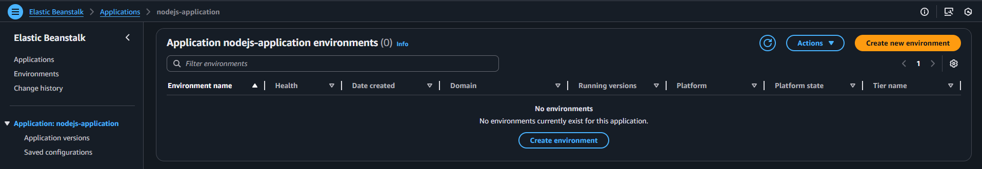

Step 1: Configure environment
1. Environment tier
- Select Web server environment (This is for apps accessed over HTTP)
2. Application information
- nodejs-application (added by default)
3. Environment information
- Environment name: nodejs-env
- Domain: umarsatti-nodejs-app.us-east-1.elasticbeanstalk.com (or leave it blank)
- Description: Environment for running simple Node.js application
4. Platform Configuration
- Platform: Node.js
- Branch: Node.js 22 running on 64-bit Amazon Linux 2023
  - Should match the version defined inside package-json file
  - Elastic Beanstalk updates it accordingly
- Version: 6.7.0
5. Application code
- Upload your code
  - Select Local file
  - Choose Node.js project .zip file from local computer
  - Make sure the project files are zipped/compressed prior
  - File: nodejs-app.zip
  - Contains: package.json, index.html, and app.js
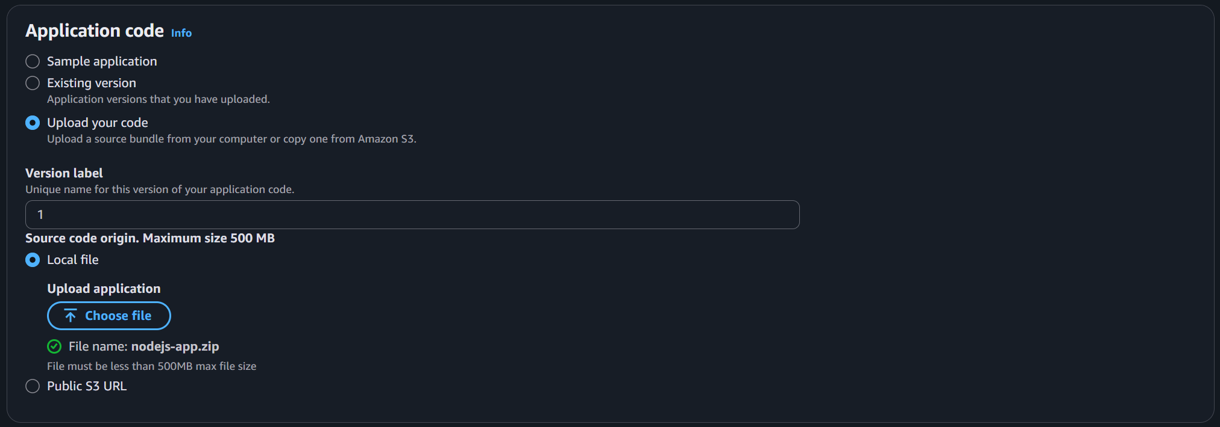
6. Presets
- Configuration presets:
  - Select High availability (for use with Load balancer)
7. Click Next to proceed

Step 2: Configure service access
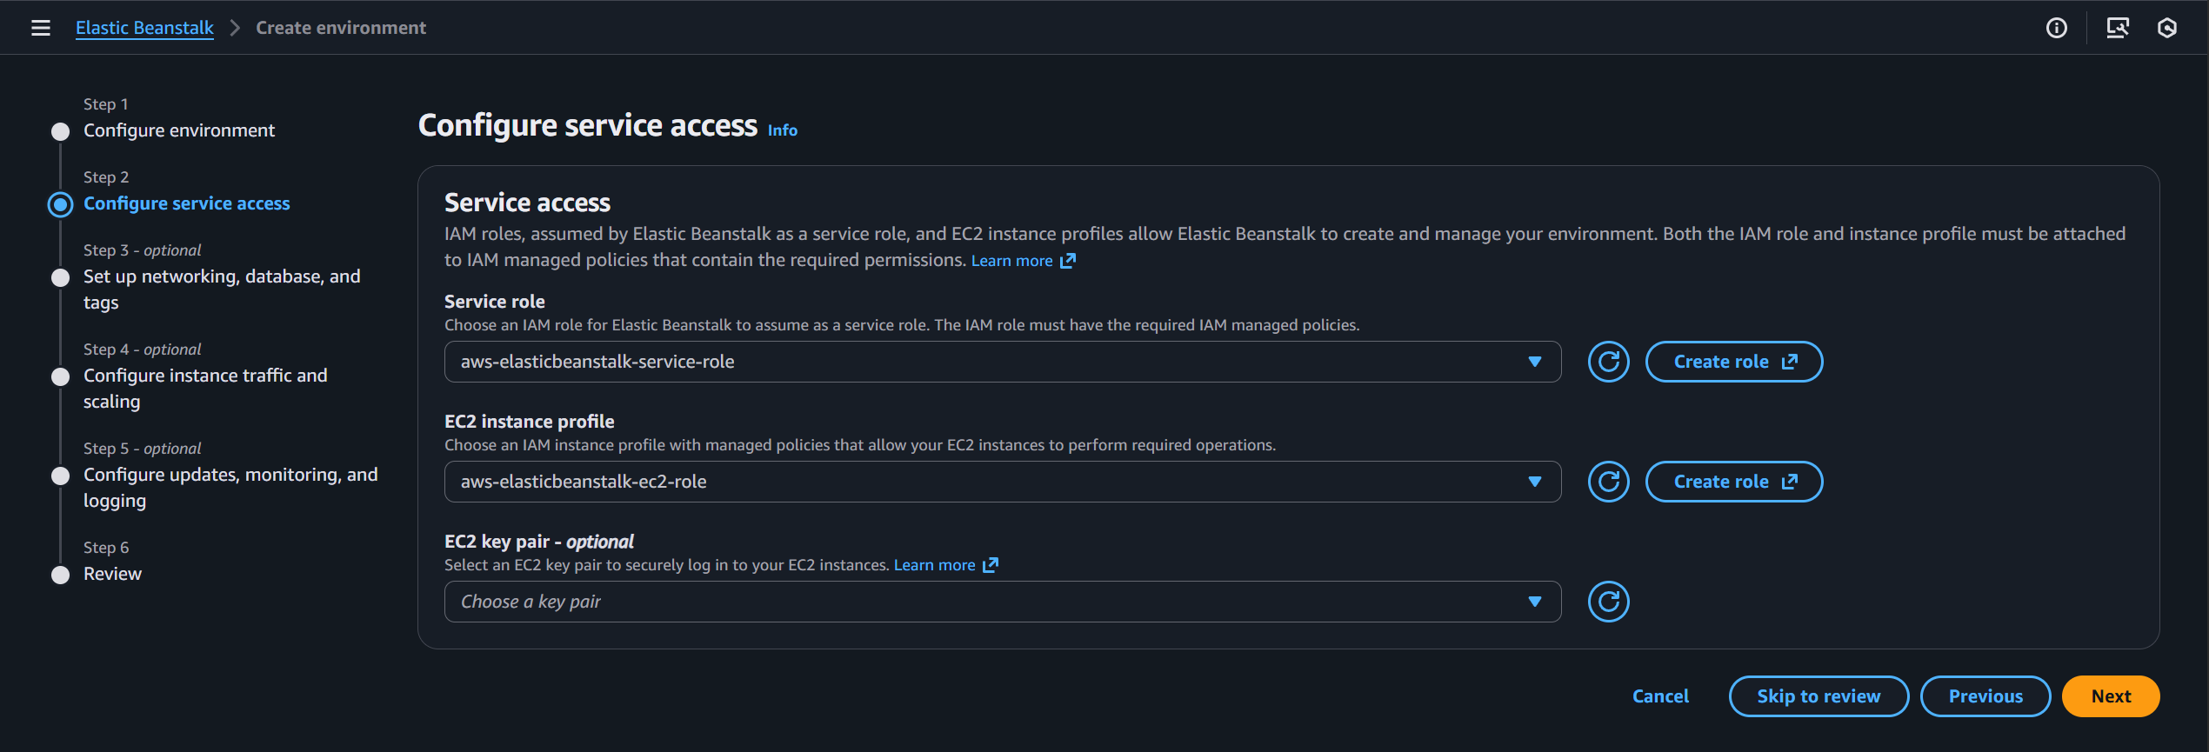
1. Service access configuration
- For Service role, select aws-elasticbeanstalk-service-role created earlier
- For EC2 instance profile, select aws-elasticbeanstalk-ec2-role created earlier
- Leave the EC2 key pair empty as SSM Sessions Manager will be used to SSH into the private EC2 instances
2. Click Next to proceed.

Step 3: Set up Networking, database, and tags
1. Instance settings
- Choose the VPC named Umarsatti-VPC (created earlier)
- Public IP address: Disabled (default)
- Instance subnets:
  - Availability Zone: us-east-1a and us-east-1b
  - Subnets: Private-Subnet-A and Private-Subnet-B
2. Database settings: None
3. Tags: None
4. Click Next to proceed
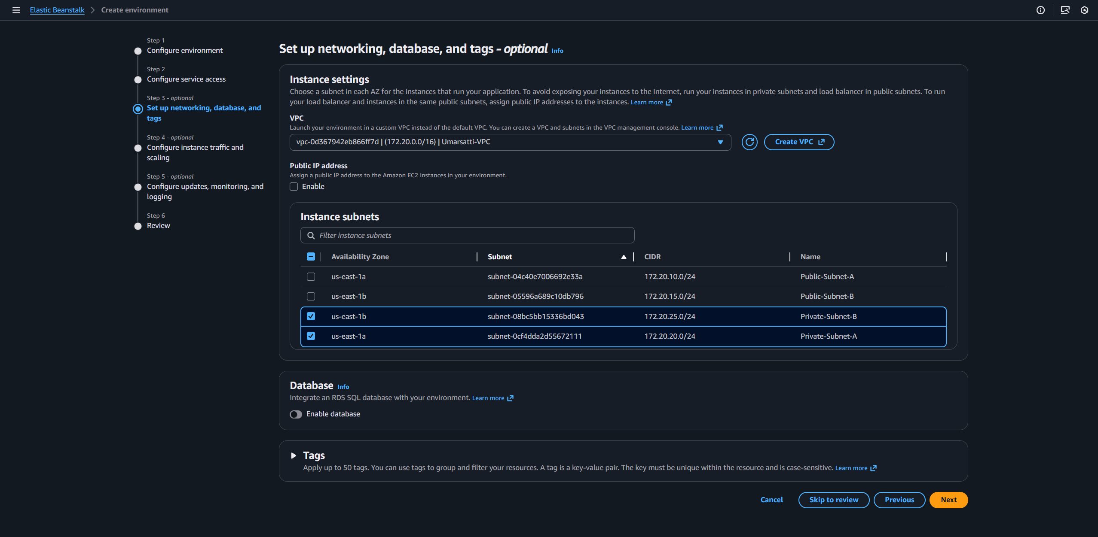

Step 4: Configure instance traffic and scaling
1. Instances
- Root volume (boot device)
  - Root volume type: General Purpose SSD (gp2)
  - Size: 10 GB
- Amazon CloudWatch monitoring
  - Monitoring interval: 1 minute
- Instance metadata service (IMDS)
  - IMDSv1: Disabled
- EC2 Security groups
  - Select EC2-SG (created in Task 1.8)
2. Capacity
- Autoscaling group
  - Environment type: Load balanced
  - Minimum instances: 1
  - Maximum instances: 2
  - Fleet composition: On-Demand instances
  - Architecture: x86_64
  - Instance types: t3.micro and t3.small
  - AMI ID: ami-054b161ba0194ab9e (default option)
  - Scaling cooldown: 60 seconds
- Scaling triggers
  - Metric: CPUUtilization
  - Statistic: Maximum
  - Unit: Percentage
  - Period: 1 minute
  - Breach duration: 2 minute
  - Upper threshold: 70%
  - Scale up increment: 1 EC2 instance
  - Lower threshold: 30%
  - Scale down increment: -1 EC2 instance
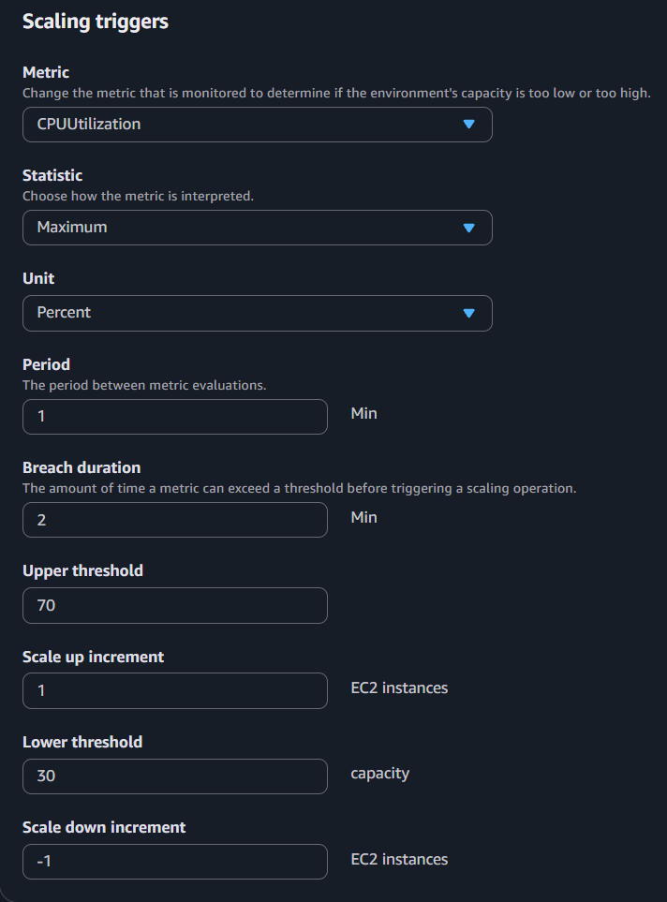
3. Load balancer network settings
  - Visibility: Public
  - Load balancer subnets: Public-Subnet-A and Public-Subnet-B
4. Load balancer type
  - Application Load Balancer
  - Dedicated
5. Listeners
  - Listener Port: 80
  - Listener Protocol: HTTP
  - Enabled: Yes
6. Rules: None
7. Log files access: Disabled
Note: Log files access can be enabled to store logs captured by Load balancer into Amazon S3 for further analysis.
8. Click Next to proceed

Step 5: Configure updates, monitoring, and logging
1. Monitoring
- Health reporting and event streaming
  - System: Enhanced Monitoring
  - CloudWatch Custom Metrics – Instance
    - Select custom metrics such as ApplicationRequests or InstanceHealth
  - CloudWatch Custom Metrics – Environment
    - Select custom metrics such as InstanceWarning or ApplicationRequests
- Health event streaming to CloudWatch Logs
  - Log streaming: Enabled
  - Retention: 7 days
  - Lifecycle: Keep logs after environment termination
2. Managed platform updates:
- Managed updates: Disabled
3. Email notifications:
- Email: umarsatti.15@gmail.com
4. Rolling updates and deployments
- Application deployments
  - Deployment policy: All at once (only for development environment)
- Configuration updates
  - Rolling update type: Disabled
- Deployment preferences
  - Ignore health check: False
  - Health threshold: Ok
  - Command timeout: 600
5. Platform software
- Container options
  - Proxy server: Nginx
- Amazon X-Ray
  - X-ray daemon: Disabled
- S3 log storage
  - Rotate logs: Disabled
- Instance log streaming to CloudWatch logs
  - Log streaming: Enabled
  - Retention: 7 days
  - Lifecycle: Keep logs after termination
- Environment properties: None
6. Click Next to proceed to the final step

Step 6: Review
- Review the whole configuration
- Apply changes by clicking the Edit button
- Proceed to create the Elastic Beanstalk environment
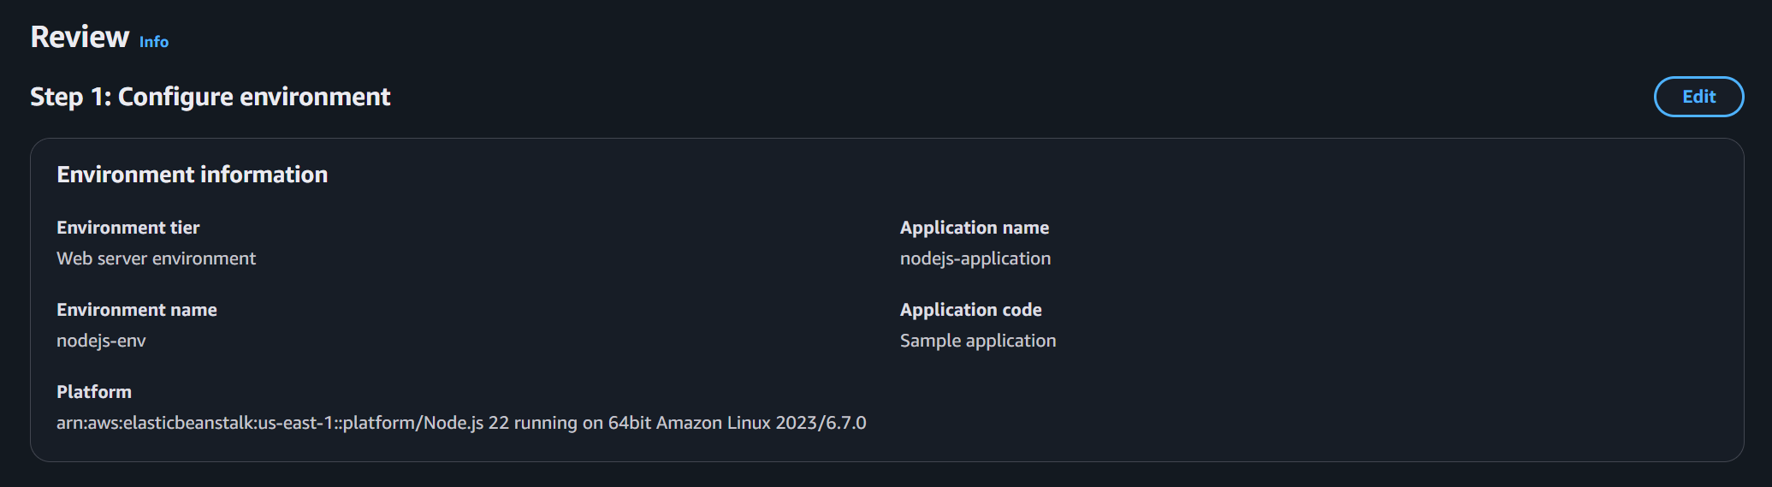
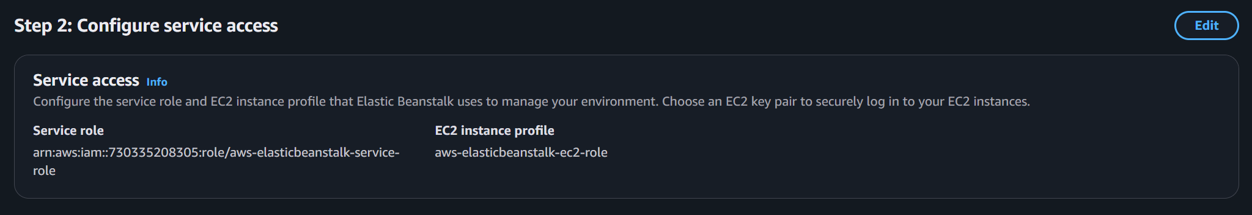
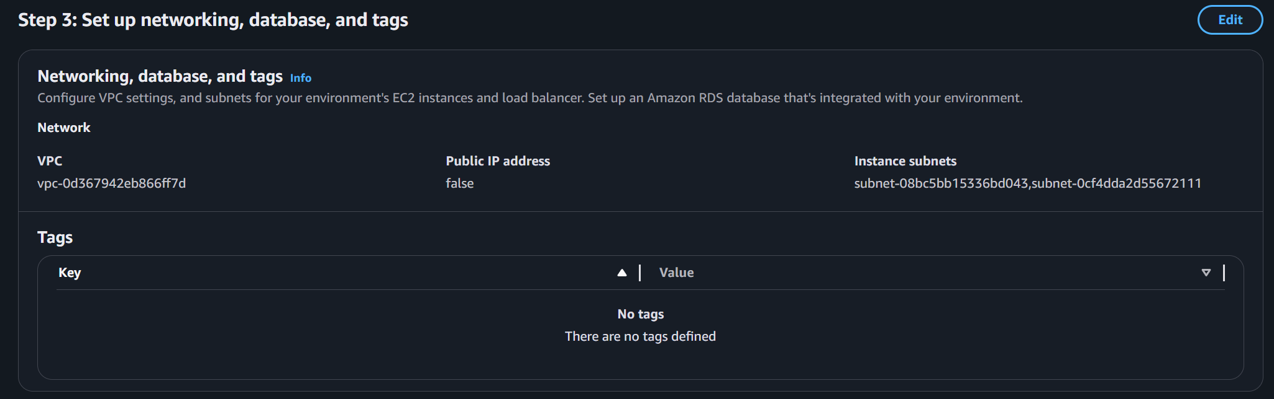
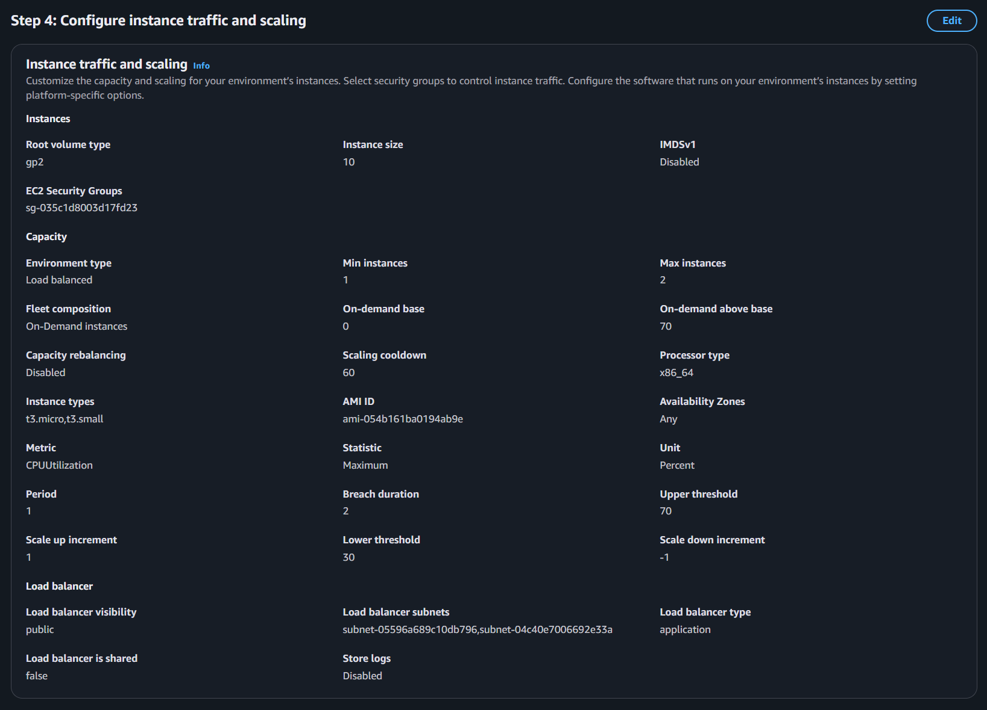
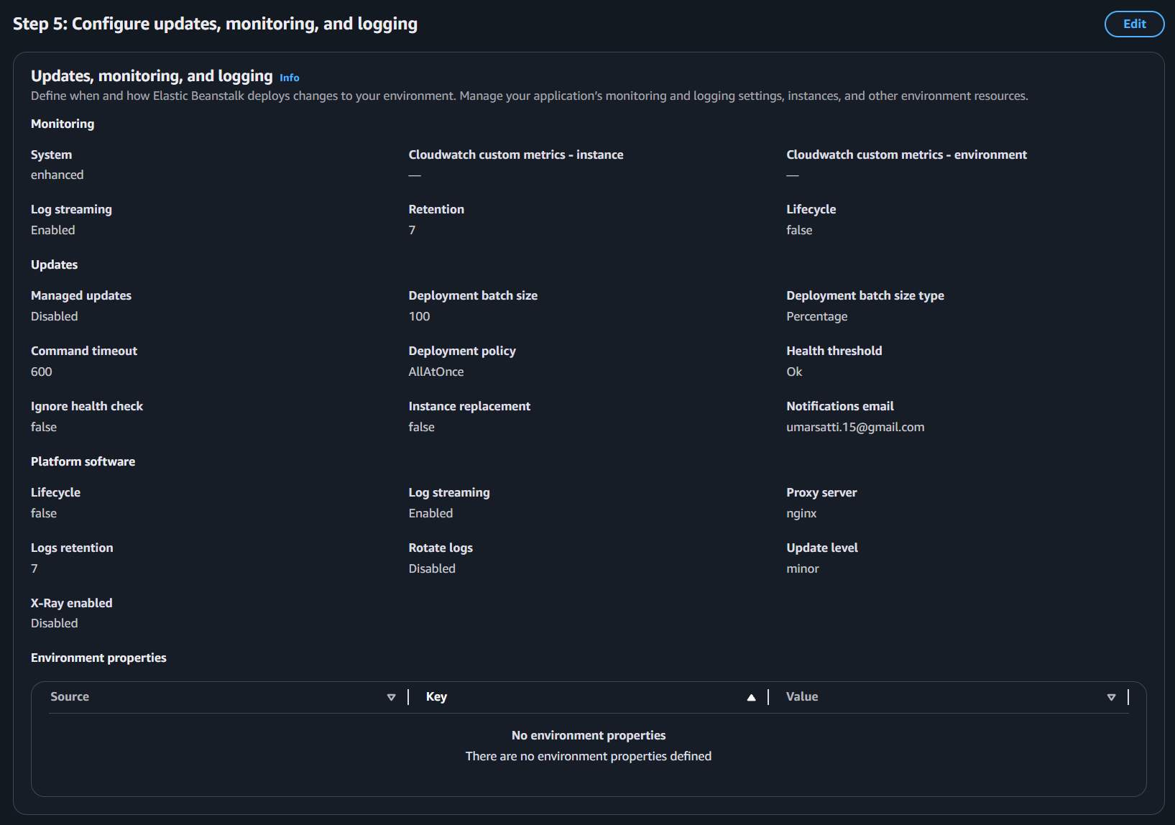

Task 3: Verify Infrastructure Deployment

Verify EC2 Instances are launched
Steps:
- Navigate to the EC2 console using the search bar above.
- Click Instances in the left navigation bar.
- Verify that the EC2 instance is launched and running.
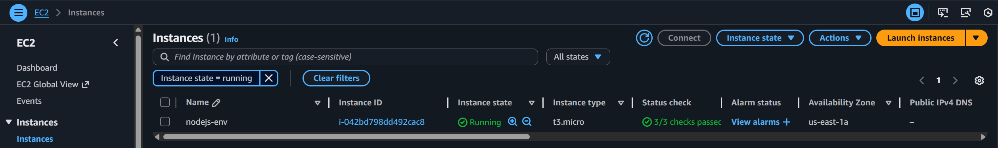

Verify Target Groups
Steps:
- In the EC2 console, scroll down the navigation bar.
- Choose the Target Groups option located in the left navigation bar and click on it.
- Select the specific target group and in the Details section, make sure the target instance is Healthy.
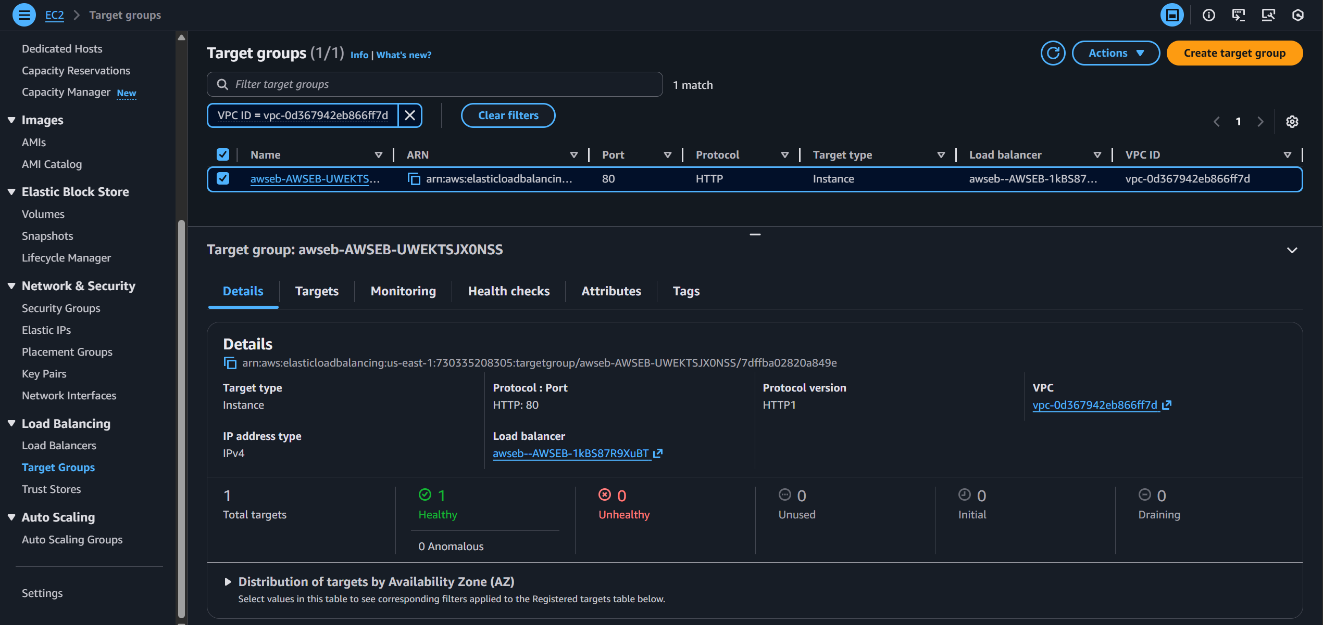

Verify Autoscaling Group
Steps:
- In the EC2 console, choose the Auto Scaling groups option located in the left navigation bar and click on it.
- Select the specific Auto Scaling group created by the Elastic Beanstalk environment.
- In the Details section, make sure the capacity settings are correct.

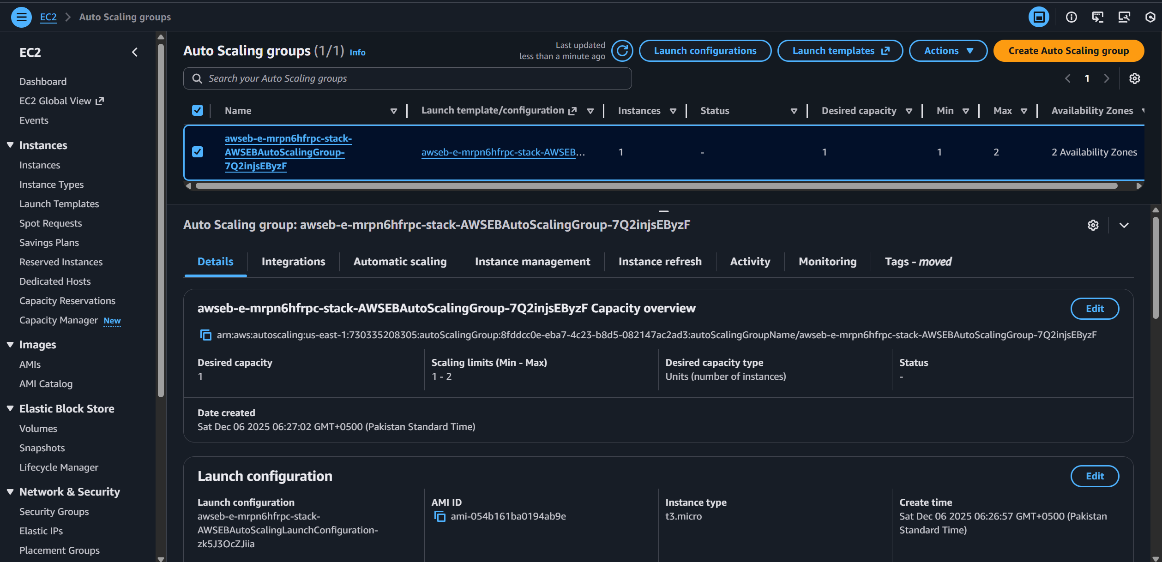

Verify ALB is working
Steps:
- In the EC2 console, choose the Load Balancers option located in the left navigation bar and click on it.
- Select the specific Load Balancer created by the Elastic Beanstalk environment.
- In the Details section, make sure the Application Load Balancer status is Active and has the correct VPC settings.

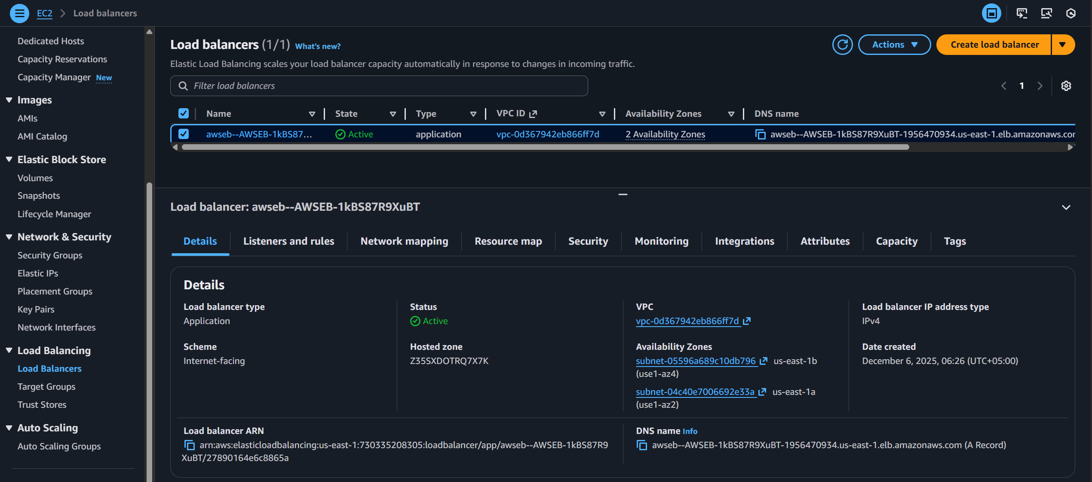

Verify if application is running using Elastic Beanstalk URL
- Nodejs-env-eba0ugqtyv3m.us-east-1.elasticbeanstalk.com
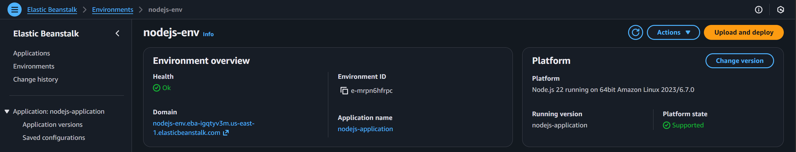
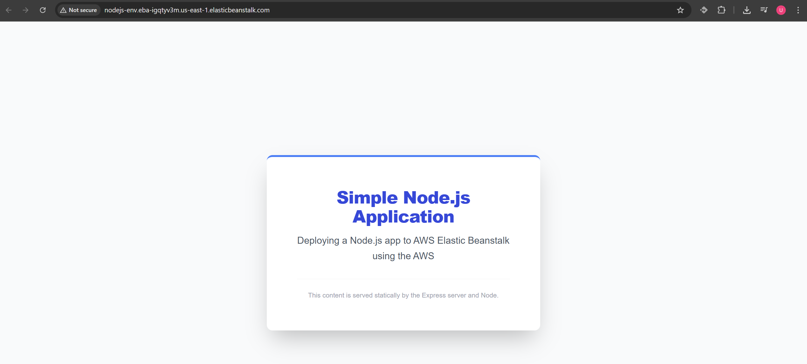

Amazon SNS
1. Subscribe to the SNS Notification
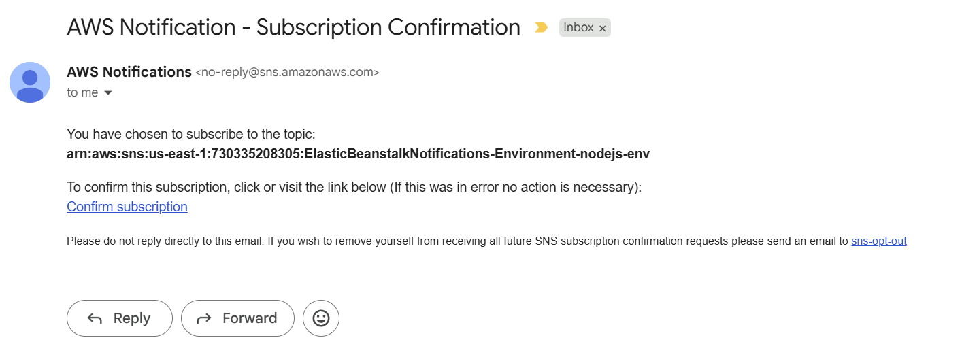
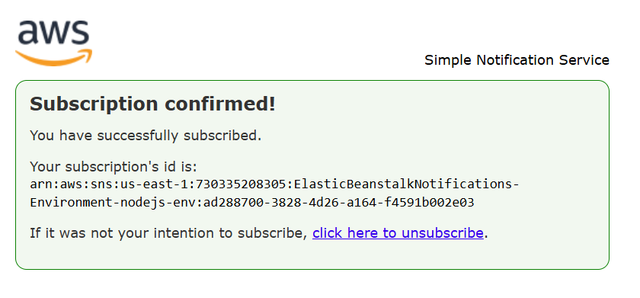
2. Receive notifications when Elastic Beanstalk successfully deploys application
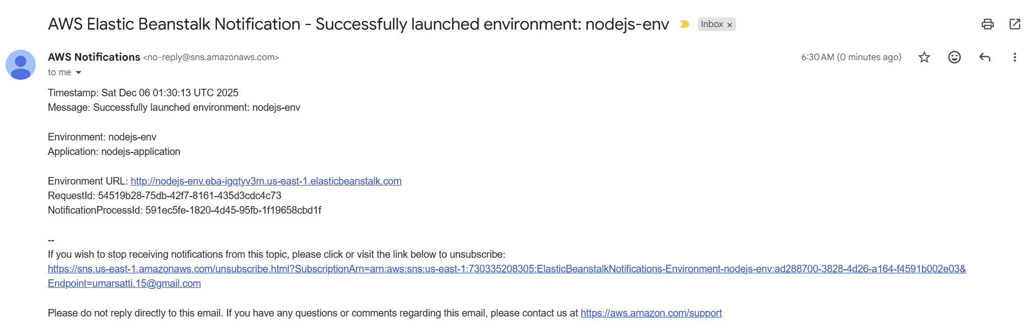

CloudWatch Log groups
Steps:
- Sign in to the AWS Management Console.
- Navigate to CloudWatch service using the search bar at the top.
- In the CloudWatch console, click Log Management located in the left navigation bar under Logs.
- Search elasticbeanstalk/nodejs-env to display a list of log groups associated with the Elastic Beanstalk environment.
- These log groups display NGINX, Apache, and Beanstalk environment related logs.
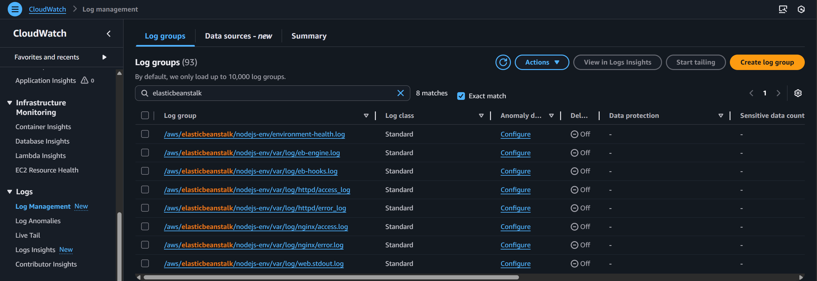

Environment Health
Steps:
- Go to Elastic Beanstalk console using the search bar.
- In the console, click Environments.
- Choose the environment created earlier named nodejs-env.
- View the Health tab.
- This displays all the custom metrics chosen during environment creation steps. Examples include HTTP responses (2xx, 3xx, 4xx etc.), latency, CPU metrics and more.

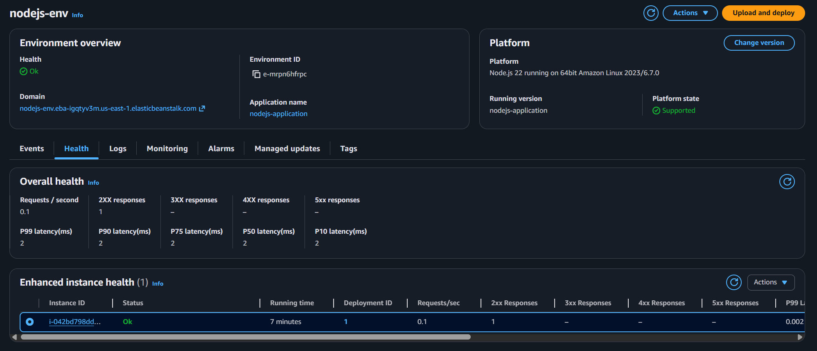

CloudWatch Alarms
Steps:
- Sign in to the AWS Management Console.
- Navigate to CloudWatch service using the search bar at the top.
- In the CloudWatch console, click All alarms located in the left navigation bar under Alarms.
- View the state of the Alarms that were configured during Elastic Beanstalk environment creation.

CloudWatch Alarm Conditions
Elastic Beanstalk automatically created two CloudWatch alarms that monitor the CPU utilization of the EC2 instances in the environment:
1. Scale-Down Alarm
- Condition: CPUUtilization < 30% for 2 consecutive datapoints within 2 minutes
- Purpose: Detects when the environment is under low load.
- Action: Triggers the Auto Scaling policy to reduce capacity (scale down the number of EC2 instances).
- Current State: IN ALARM, meaning CPU is currently below the 30% threshold.
2. Scale-Up Alarm
- Condition: CPUUtilization > 70% for 2 consecutive datapoints within 2 minutes
- Purpose: Detects high load or increased demand.
- Action: Triggers the Auto Scaling policy to add an EC2 instance (scale up).
- Current State: OK, meaning CPU is not above 70% at this moment.

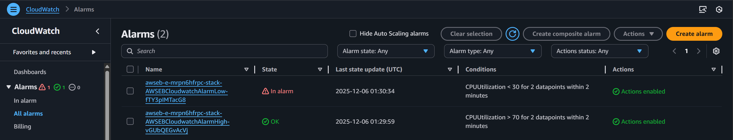

Using CloudWatch Alarms
Step 1: Verify SSM agent is installed on EC2
- Go to Systems Manager
- Select Fleet Manager tab located on the left
- Verify that EC2 named nodejs-env is present and running
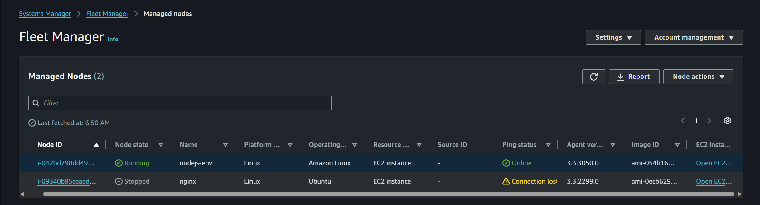
Step 2: SSH into EC2 instance
- Go to EC2 Console and select the EC2 instance
- Click Connect located on the top right
- Navigate to Session Manager tab and click Connect

Step 3: Using stress utility to increase CPU usage on this instance
- Install stress utility using:
  - sudo yum install install stress-ng -y
- Run stress command
  - stress-ng --cpu 0 --cpu-load 90 --timeout 360
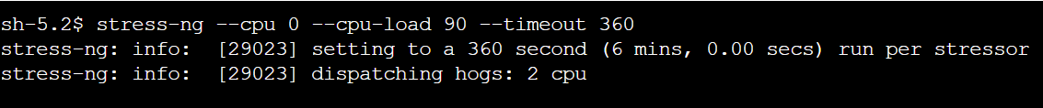
- This stress command is used to increase the CPU usage of EC2 instance up to 90%.
- Notifications are sent to the Email regarding Environment health and status of EC2 instances
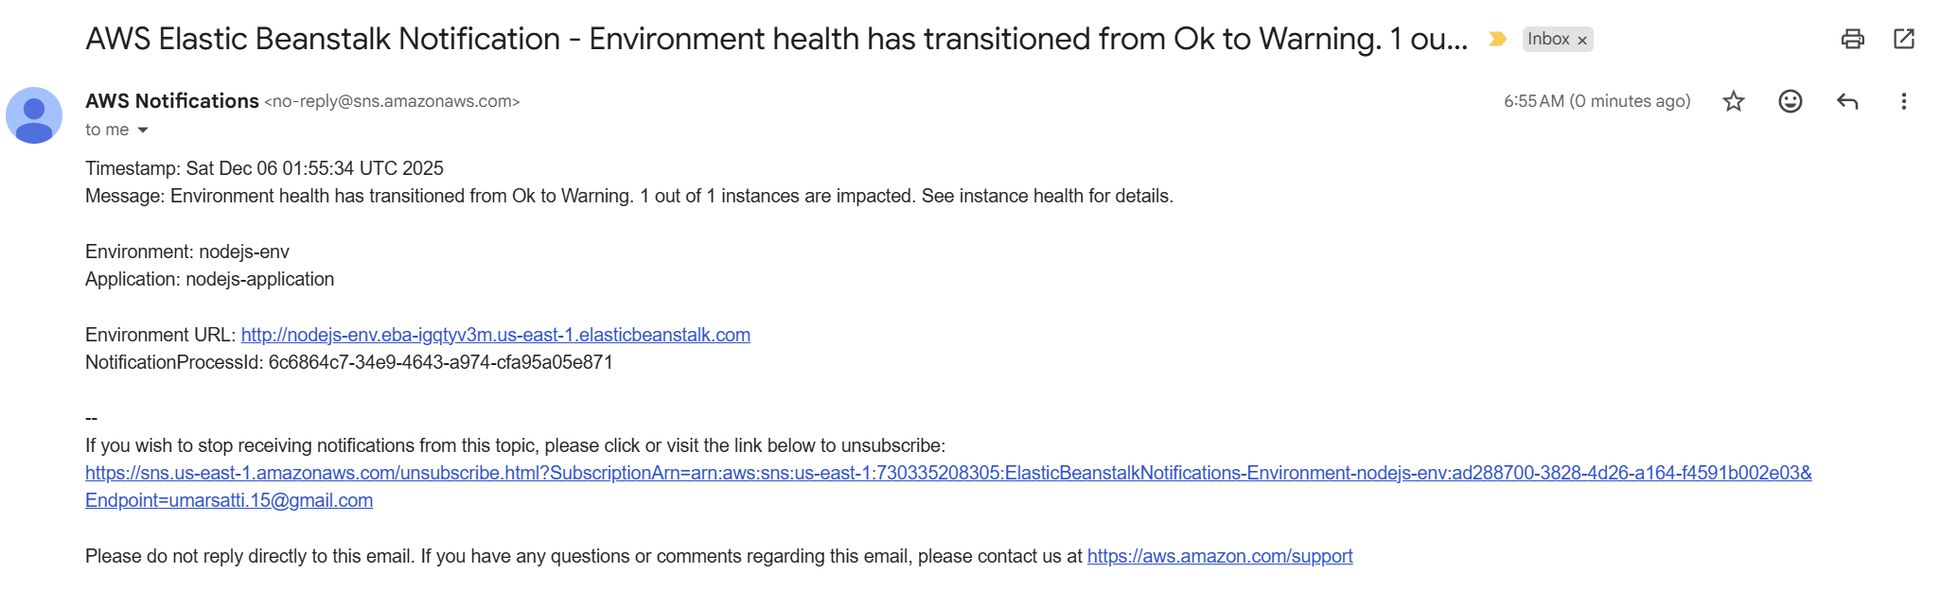
Step 4: Verify CloudWatch Alarms
- Go to CloudWatch console
- Select All alarms under Alarms tab
- It should display the 70% CPUUtilization condition in ALARM state and transition the 30 % CPUUtilization condition in OK state because the CPU usage is now around 90% (greater than 70%).
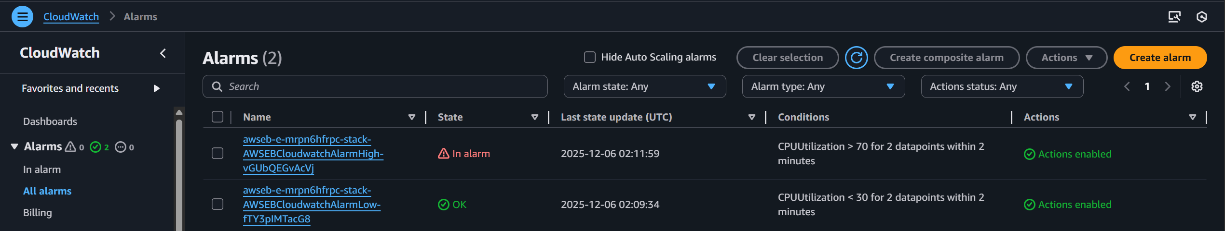
Step 5: Confirm EC2 creation
- Navigate to the EC2 console using the search bar
- Choose the Instances option in the left navigation bar
- A new instance should be deployed as shown in the image below
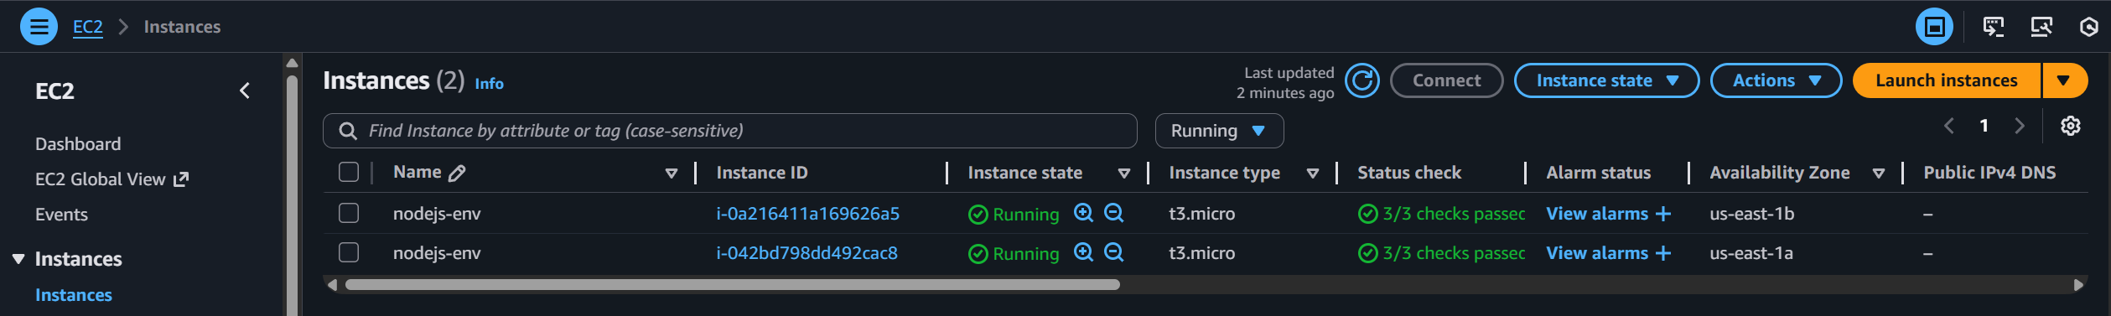
Step 6: Target groups
- Navigate to the Target groups within the EC2 console
- Confirm that newly launched instead has been registered as a Healthy target
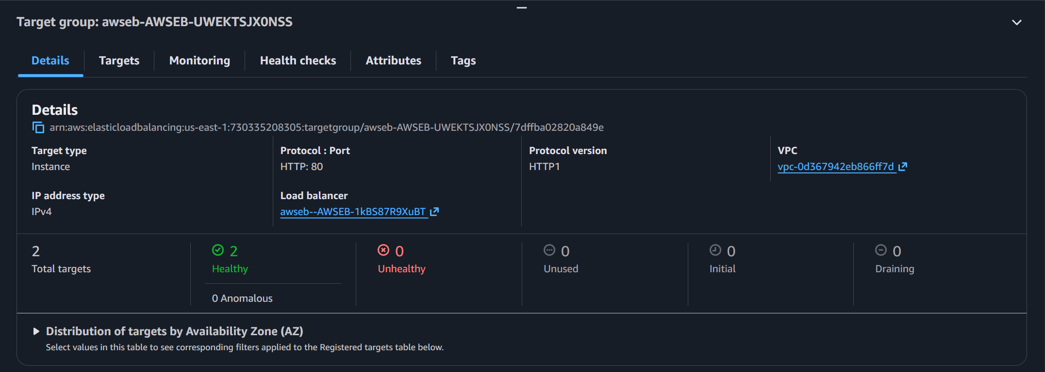
Step 7: Elastic Beanstalk events
- The scaling events caused by CloudWatch Alarms produced events in Elastic Beanstalk Events section
- Indicates the Environment health transitioned from Ok to Degraded
- An instance was added once the CPUUtilization went up (above 70%).
- The instance was terminated once the CPUUtilization went down (below 70%).
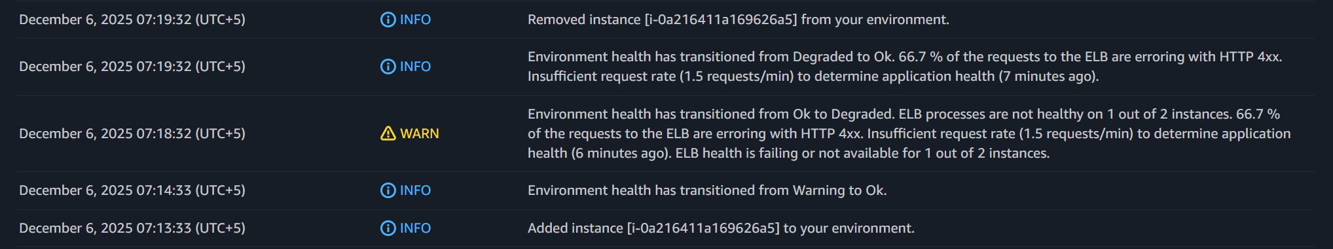

Task 4: Update Application Code and Redeploy
This task involves making changes to the Node.js application and deploying the updated version to the existing Elastic Beanstalk environment.

4.1 Prepare Updated Application Code
Make any required modifications to the Node.js project (for example, updating index.html, adding routes, or changing text).
After making these changes:
- Ensure the project contains the files: app.js, package.json, and public/ folder
- Create a ZIP file of the application.
Important: Files must be at the root level of the ZIP, not inside a parent folder.
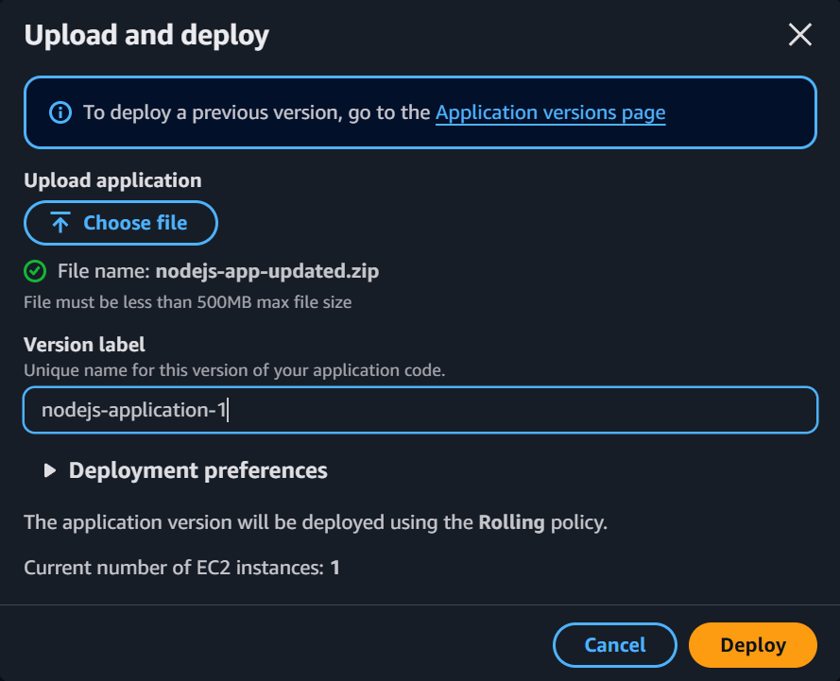

4.2 Upload Updated Code in Elastic Beanstalk
- Open the AWS Elastic Beanstalk console.
- Select the application you previously created.
- Open the environment named nodejs-env.
- Click Upload and Deploy on the top right.
- Choose the ZIP file containing your updated application code.
- Provide a version label (optional), then click Deploy.
Elastic Beanstalk will automatically handle:
- Uploading the version
- Rebuilding the environment
- Deploying the new code to EC2 instances
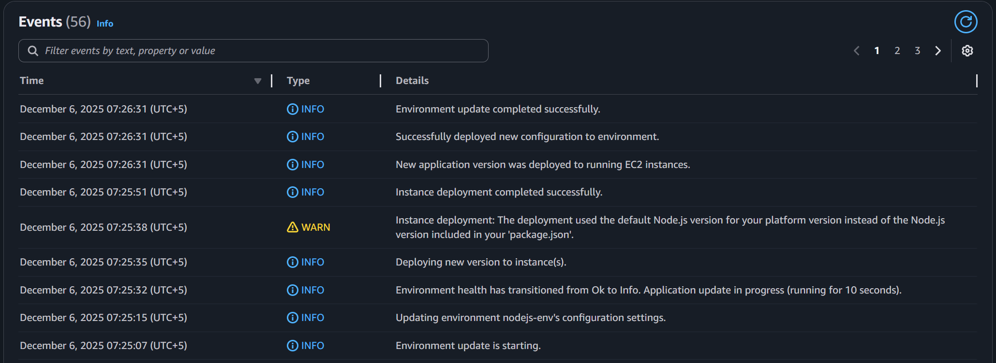

4.3 Validate the Deployment
- After successful deployment, test the application using Elastic Beanstalk URL:
  - nodejs-env.eba-igqtyv3m.us-east-1.elasticbeanstalk.com
- Open this URL in the browser to confirm that your changes are reflected in the deployed application.

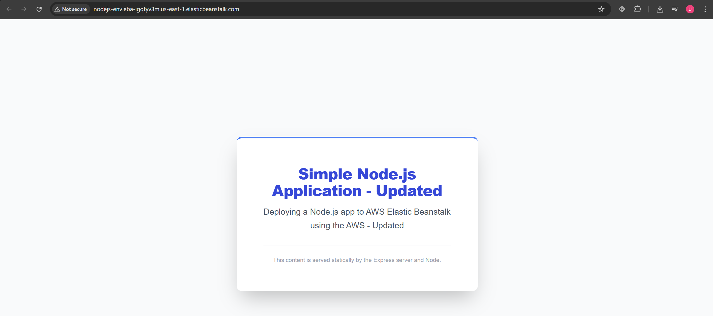

Task 5: Clean Up
The final step is to remove the AWS resources to avoid unnecessary charges.
5.1 Terminate the Elastic Beanstalk Environment
- Go to the Elastic Beanstalk console.
- Click Environments from the left sidebar.
- Select the environment named nodejs-env.
- Click the Actions button (top right).
- Choose Terminate environment.
Elastic Beanstalk will:
- Terminate the EC2 instances
- Remove the load balancer
- Delete Auto Scaling resources
- Clean up associated health checks, alarms, and configuration
Note: Termination may take several minutes.

5.2 Optional: Delete the Application
If the application is no longer required:
- Return to the Elastic Beanstalk Applications page.
- Select your application (nodejs-application).
- Click Actions and then click Delete Application.
This completes the cleanup process and prevents any further AWS charges.
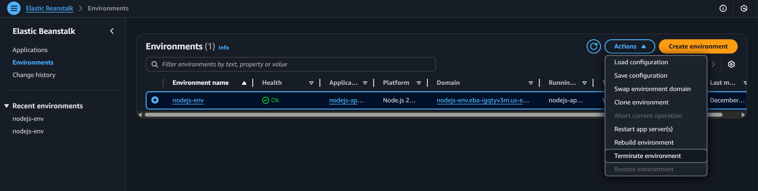
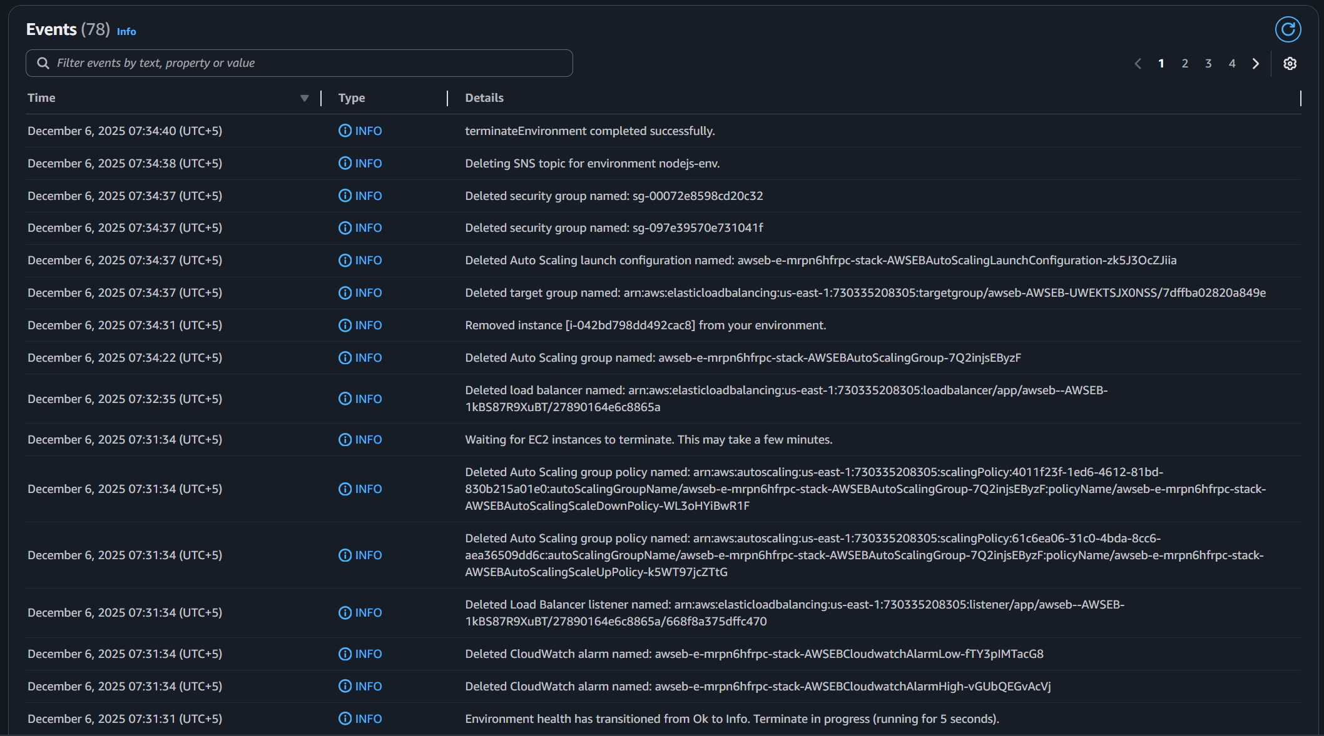

Task 6: Troubleshooting
The following issues were encountered during deployment, testing, and scaling of the Elastic Beanstalk environment. Each issue includes the observed error, root cause, and exact steps taken to resolve it.
Issue 1: Elastic Beanstalk IAM Role Error
Problem Description:
When configuring IAM Role for the Elastic Beanstalk environment, an error occurred.
Select a service role that has the 'AWSElasticBeanstalkManagedUpdatesCustomerRolePolicy' managed policy.
Root Cause:
Elastic Beanstalk was configured to use the default service-linked role (AWSServiceRoleForElasticBeanstalk), which does not include the required policy for Managed Updates (an optional feature but auto-selected). Elastic Beanstalk only allows Managed Platform Updates when using a customer-managed service role with the correct permissions.
Solution:
Create a custom IAM role named aws-elasticbeanstalk-service-role and attach the following managed policies:
- AWSElasticBeanstalkEnhancedHealth
- AWSElasticBeanstalkManagedUpdatesCustomerRolePolicy
Then update the environment configuration to use this new service role. After assigning the custom role, Managed Updates can be enabled successfully and the user can move on to the next step.

Issue 2: CloudWatch Alarms Did Not Immediately Trigger During CPU Stress Test
Problem Description:
During testing of Auto Scaling using the stress and stress-ng utilities on the EC2 instance, CloudWatch alarms initially did not transition to In Alarm state, and scaling actions did not trigger immediately.
Root Cause:
CloudWatch metrics are collected at 1-minute intervals, and alarm evaluation requires:
- 2 datapoints
- across 2 consecutive periods
This introduces a 2–3 minute delay before alarms trigger. Additionally, initial CPU spikes may not breach the threshold long enough to satisfy the evaluation window.
Solution:
- Increased the duration of the stress test:
- stress-ng --cpu 0 --cpu-load 95 --timeout 300
- Ensured the CPU load remained above the 70% scale-up threshold for multiple minutes.
Once the CPU remained consistently high, the “High CPU” alarm transitioned to In Alarm state, and a new EC2 instance was launched successfully.

Issue 3: stress-ng Failed With “temp-path '.' must be readable and writable”
Problem Description:
Running stress-ng on the EC2 instance returned:
- aborting: temp-path '.' must be readable and writable
Root Cause:
The command was executed inside a restricted directory where the user did not have write permissions. The stress-ng utility requires the ability to write temporary files during execution.
Solution:
Change to a writable directory such as the home directory or /tmp before running cd ~ OR cd /tmp to move to the correct directory and then running:
- stress-ng --cpu 0 --cpu-load 95 --timeout 300
This resolved the permission issue and allowed the stress test to run properly.

Issue 4: Logs Not Showing in the Elastic Beanstalk Console
Problem Description:
Under the Logs tab, no log files appeared even after deployment.
Root Cause:
Elastic Beanstalk does not automatically pull logs unless a request is made. Logs are stored directly on the EC2 instance and must be manually retrieved.
Solution:
Use the Request Logs button in the EB console:
- Request last 100 lines or
- Request full logs
Once triggered, Elastic Beanstalk fetches the logs temporarily, and they appear in the console or can be downloaded as a ZIP folder. This behavior is normal for EB-managed environments.

